
GURU NANAK INSTITUTIONS TECHNICAL CAMPUS (AUTONOMOUS)
SCHOOL OF ENGINEERING AND TECHNOLOGY

Department of Computer Science and Engineering

Academic year (2024-2025)

PROJECT BASED LEARNING

Max Marks - 10
_____________________________________________________________________________________________
Name of the Lab & Code: 22PC0CS16
Year/ Sem : 3rd/1st
Section: CSE-2
Roll Number: 23WJ1A0575
Name of the Student: G.Sharvani
Topic Name:
Introduction:
LAN Switching using VLANs in Cisco Packet Tracer

LAN Switching with VLANs (Virtual Local Area Networks) is an important concept in computer networks that helps in logically segmenting a single physical network into multiple broadcast domains. VLANs improve security, reduce congestion, and simplify management by grouping users and devices logically rather than physically. In Cisco Packet Tracer, VLANs are created on switches to provide isolation between departments such as HR, Finance, and Engineering, while still being connected to the same switch. Inter-VLAN communication can also be achieved using a router or Layer 3 switch.

Experiment no's to be used for implemented :

1. Basic LAN Configuration in Cisco Packet Tracer
2. Switch Configuration and Port Assignments
3. VLAN Creation and Inter-VLAN Communication

Given Input:
- Cisco Packet Tracer software
- One or more Cisco switches
- End devices (PCs, Laptops)
- Router (for inter-VLAN routing, if required)
- IP addressing scheme for each VLAN
- Commands for configuring VLANs (vlan, interface, switchport access vlan, etc.)

Expected Output:
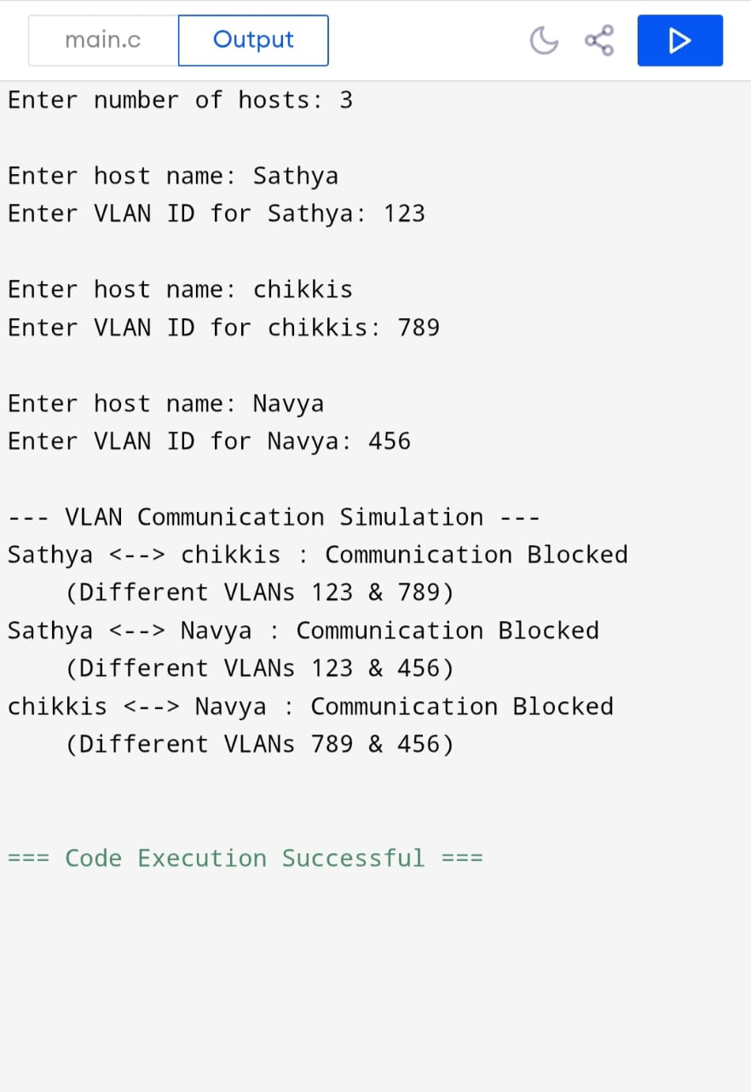

Student Signature Faculty Signature

